Module (JQuery Basic, Effects & Advanced) – 5

1. What is jQuery? jQuery is a fast, small, and feature-rich JavaScript library. It makes things like HTML document traversal and manipulation, event handling, animation, and Ajax much simpler with an easy-to-use API that works across a multitude of browsers. With a combination of versatility and extensibility, jQuery has changed the way that millions of people write JavaScript.
2. How to Apply CSS Using JQuery, How to Add Class and Remove Class in Jquery ,

ADD CLASS

<!DOCTYPE html>

<html lang="en">

<head>

<meta charset="UTF-8">

<meta http-equiv="X-UA-Compatible" content="IE=edge">

<meta name="viewport" content="width=device-width, initial-scale=1.0">

<title>Document</title>

<script src="https://cdnjs.cloudflare.com/ajax/libs/jquery/3.6.4/jquery.min.js" integrity="sha512-pumBsjNRGGqkPzKHndZMaAG+bir374sORyzM3uulLV14lN5LyykqNk8eEeUlUkB3U0M4FApyaHraT65ihJhDpQ==" crossorigin="anonymous" referrerpolicy="no-referrer"></script>

<style>

.one{

background-color: aquamarine;

font-family: monospace;

font-size: x-large;

color: aliceblue;

}

</style>

</head>

<body>

<p class="one">bbnvcv vvxvchgbc </p>

<button>home</button>

<div class="one">hddnnb hbvvgbdg</div>

<script>

$(document).ready(function () {

$("button").click(function () {

$("p,div").addClass("one")

})

</script>

</body>

</html>

REMOVE CLASS

<!DOCTYPE html>

<html lang="en">

<head>

<meta charset="UTF-8">

<meta http-equiv="X-UA-Compatible" content="IE=edge">

<meta name="viewport" content="width=device-width, initial-scale=1.0">

<title>Document</title>

<script src="https://cdnjs.cloudflare.com/ajax/libs/jquery/3.6.4/jquery.min.js" integrity="sha512-pumBsjNRGGqkPzKHndZMaAG+bir374sORyzM3uulLV14lN5LyykqNk8eEeUlUkB3U0M4FApyaHraT65ihJhDpQ==" crossorigin="anonymous" referrerpolicy="no-referrer"></script>

<style>

.one{

background-color: aquamarine;

font-family: monospace;

font-size: x-large;

color: aliceblue;

}

</style>

</head>

<body>

<p class="one">bbnvcv vvxvchgbc </p>

<button>home</button>

<div class="one">hddnnb hbvvgbdg</div>

<script>

$(document).ready(function () {

$("button").click(function () {

$("p,div").removeClass("one")

$("p,div").toggleClass("one")

})

})

</script>

</body>

</html>

Jquery Animation

<!DOCTYPE html>

<html lang="en">

<head>

<meta charset="UTF-8">

<meta http-equiv="X-UA-Compatible" content="IE=edge">

<meta name="viewport" content="width=device-width, initial-scale=1.0">

<title>Document</title>

<script src="https://ajax.googleapis.com/ajax/libs/jquery/3.6.1/jquery.min.js"></script>

<style>

div

{

height: 150px;

width: 150px;

background-color: blue;

left: 50%;

position: relative;

}

</style>

</head>

<body>

<button>Left</button>

<div>

</div>

<script>

$(document).ready(function()

{

$("button").click(function()

{

$("div").animate({left:'50'});

})

})

</script>

</body>

</html>

1. How to create slider with animation?

<!DOCTYPE html>

<html lang="en">

<head>

<meta charset="UTF-8">

<meta http-equiv="X-UA-Compatible" content="IE=edge">

<meta name="viewport" content="width=device-width, initial-scale=1.0">

<script src="https://cdnjs.cloudflare.com/ajax/libs/jquery/3.6.4/jquery.min.js" integrity="sha512-pumBsjNRGGqkPzKHndZMaAG+bir374sORyzM3uulLV14lN5LyykqNk8eEeUlUkB3U0M4FApyaHraT65ihJhDpQ==" crossorigin="anonymous" referrerpolicy="no-referrer"></script>

<style>

div{

height: 50px;

width: 50px;

background-color: aqua;

position: absolute;

}

</style>

<title>Document</title>

</head>

<body>

<button>hello</button>

<div ></div>

<script>

$(document).ready(function () {

$("button").click(function () {

var div=$("div")

div.animate({left:'200px'})

$("div").animate({height:'200px'})

$("div").animate({width:'200px'})

$("div").animate({height:'500px'})

$("div").animate({width:'500px'})

})

})

</script>

</body>

</html>

1. Event bubbling tickling example

**Example:**

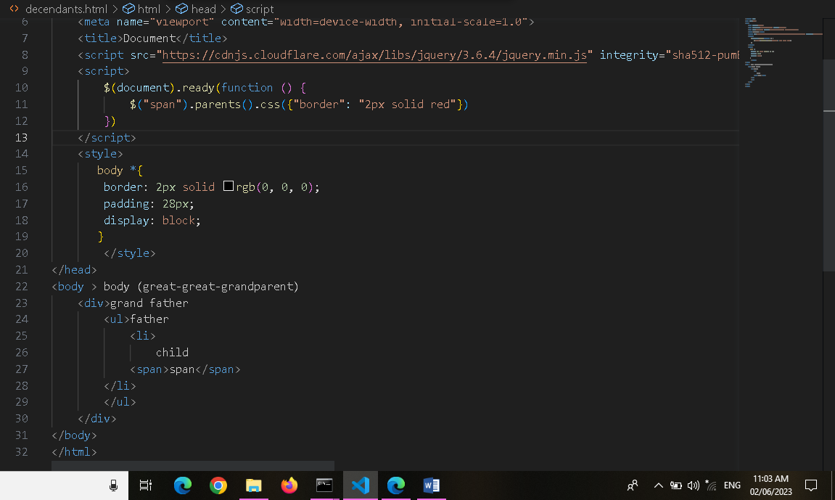

**Outpot:**

